Phylum  System | Muscular | Skeletal | Reproductive | Other Key Facts | Image
Porifera  Sponges | No Muscle cells | Jelly-like mesohyl is sandwiched between two thin layers of cells. The mesohyl functions as an endoskeleton in most sponges, More commonly, the mesohyl is stiffened by mineral spicules, by spongin fibers or both | Asexual budding, Most species use sexual reproduction, releasing sperm cells into the water to fertilize ova .  Some are Hermaphrodites. | Sessile: stationary part of life cycle  Some sponges are carnivores | 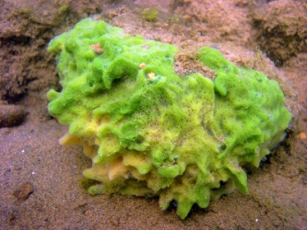
1.
2.
3.
4.
5.
6.
7.
8.
9.
10.

